MS2 Trial 1

**3 primer sets**

**2 primer concentrations**

**2 temperatures**

Using MS2 cDNA, PCR was done with 3 primer sets (IDMO00-01, IDMO02-03, IDMO04-05) at 2 different concentrations (.2 uM and .1 uM). These mixes were then run with the same parameters except the annealing temperature. Temp. 1 was 60 0C and Temp. 2 was 63 0C.

For both temperatures, the sample names correspond to the different primer concentrations as follows:

|  |  |
| --- | --- |
| Sample Label: | Primer |
| 1: Assay 1 | IDMO00-01 |
| 2: Assay 2 | IDMO02-03 |
| 3: Assay 3 | IDMO04-05 |

Human errors:

* The capillary holding Assay 3 (0.1 uM) for Temp. 2 broke before the samples were loaded into the machine so that sample is depicted in the graphs as a flat horizontal line at y=0
* Only one negative control was used for each temperature to see if primer-dimers could be detected/quantified. However, no primer was added to that mix so the data for the negative control should be discarded.

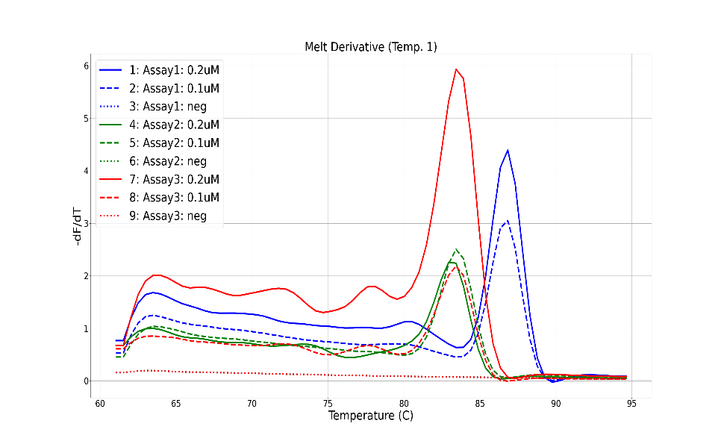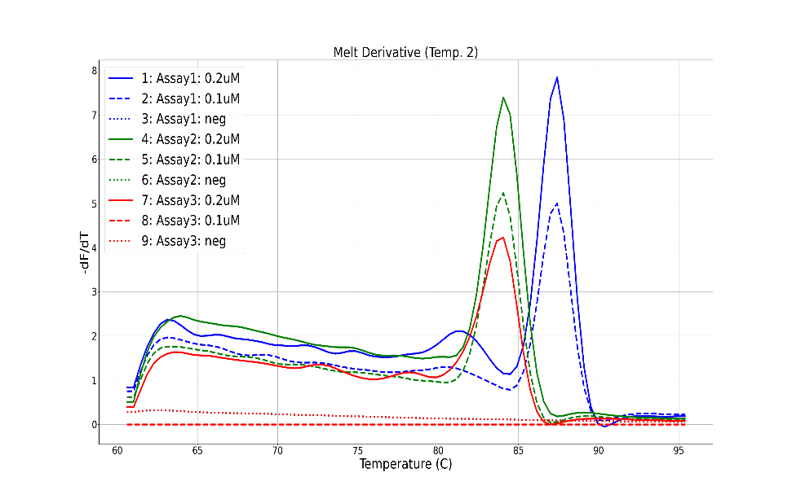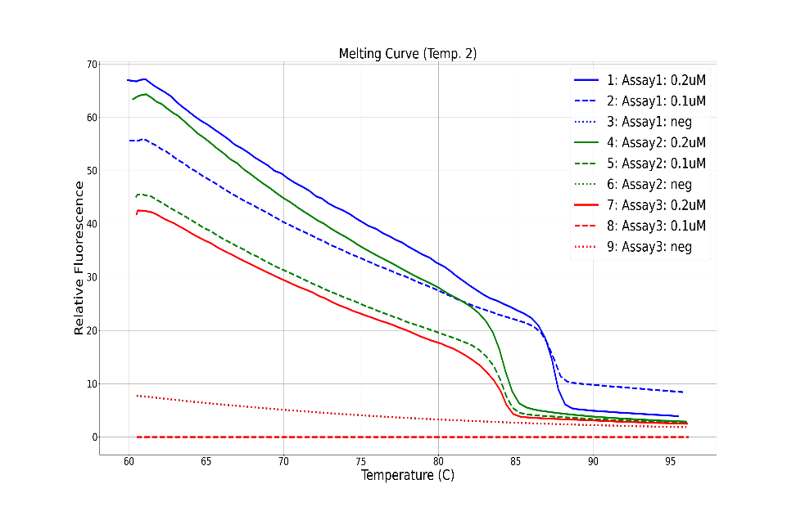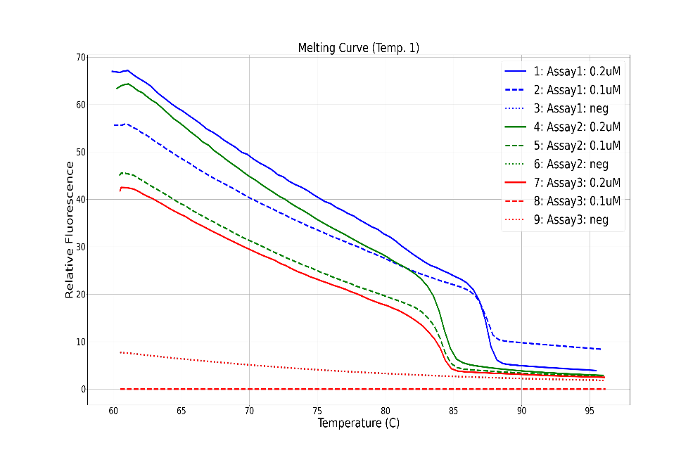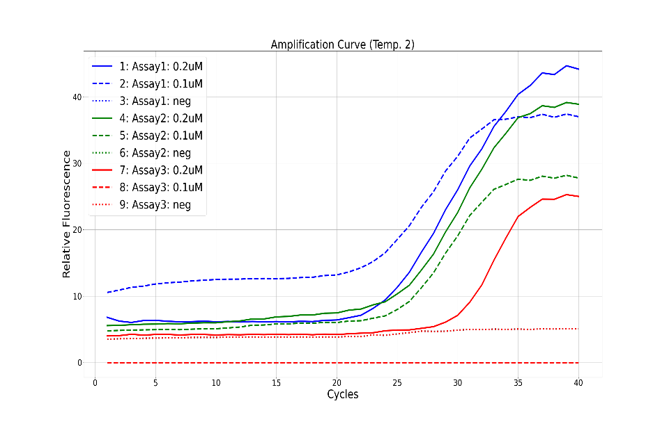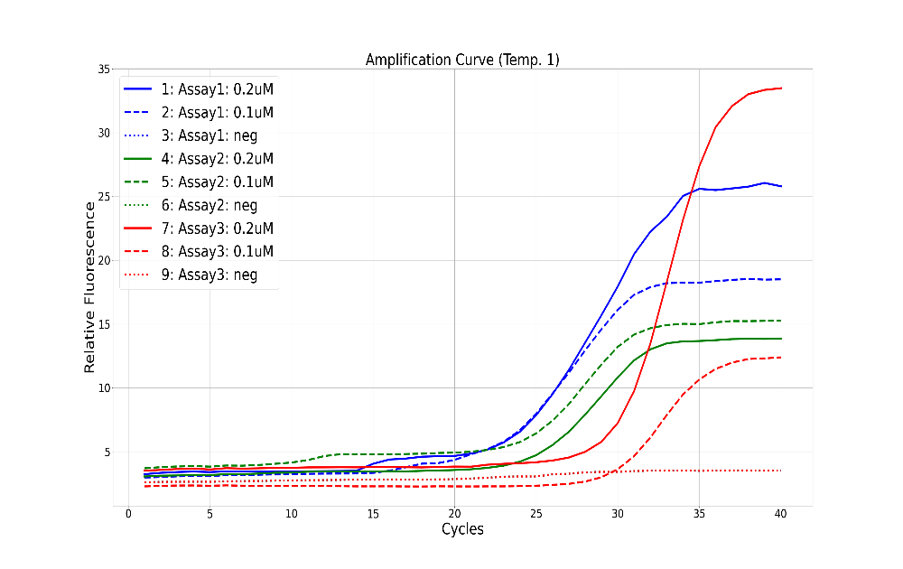

|  |  |
| --- | --- |
| Assay/dilution | Tm value |
| 1/0.2uM | 87.39 |
| 1/0.1uM | 87.47 |
| 2/0.2uM | 83.58 |
| 2/0.1uM | 83.62 |
| 3/0.2uM | 83.31 |
| 3/0.1uM | x |

|  |  |
| --- | --- |
| Assay/dilution | Tm value |
| 1/0.2uM | 86.58 |
| 1/0.1uM | 86.91 |
| 2/0.2uM | 82.73 |
| 2/0.1uM | 83.20 |
| 3/0.2uM | 82.89 |
| 3/0.1uM | 82.97 |

MS2 Trial 2

For this run, the same assays, dilutions, and temperatures as Trial 1 were utilized.

Errors fixed:

* No capillaries were broken while loading the assays.
* 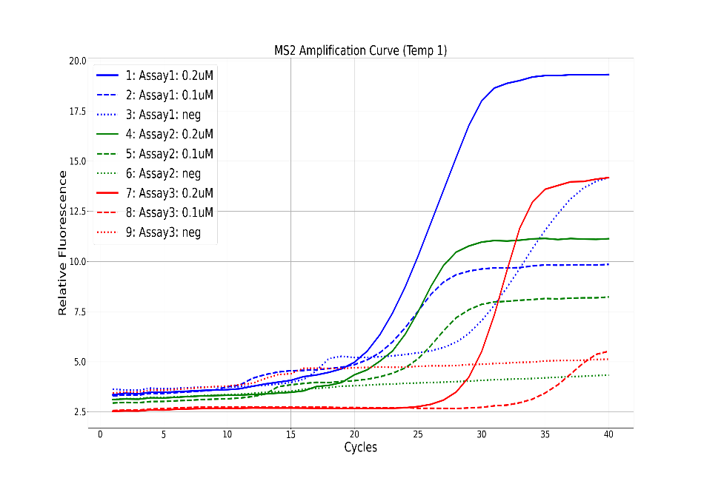The negative controls contain 0.2uM primers with no template.

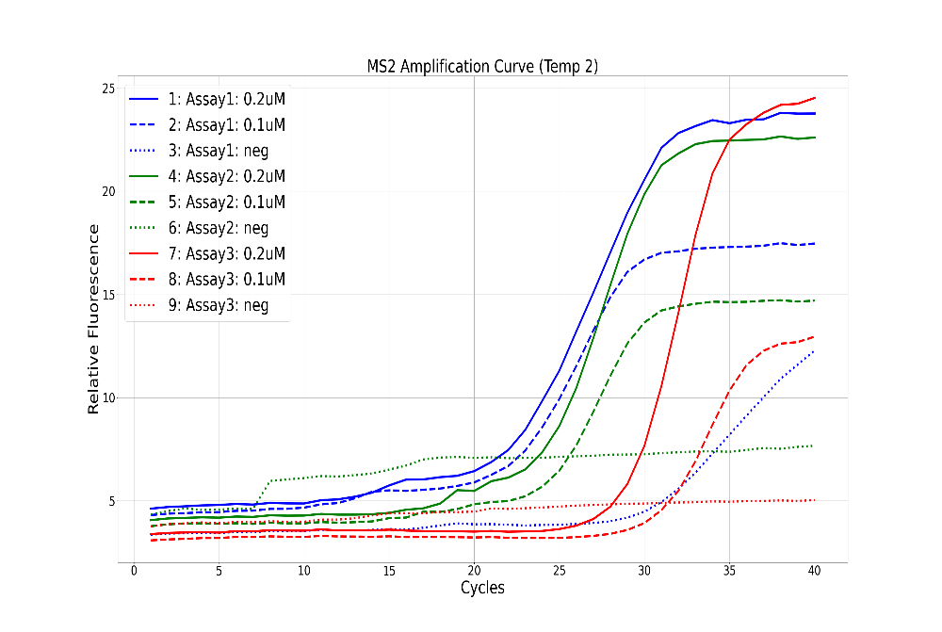

|  |  |
| --- | --- |
| Assay/dilution | Cp value |
| 1/0.2uM | 21.64 |
| 1/0.1uM | 21.59 |
| 2/0.2uM | 23.25 |
| 2/0.1uM | 23.11 |
| 3/0.2uM | 27.74 |
| 3/0.1uM | 29.53 |

|  |  |
| --- | --- |
| Assay/dilution | Cp value |
| 1/0.2uM | 20.85 |
| 1/0.1uM | 21.00* |
| 2/0.2uM | 21.01 |
| 2/0.1uM | 22.19 |
| 3/0.2uM | 27.42 |
| 3/0.1uM | 32.70 |

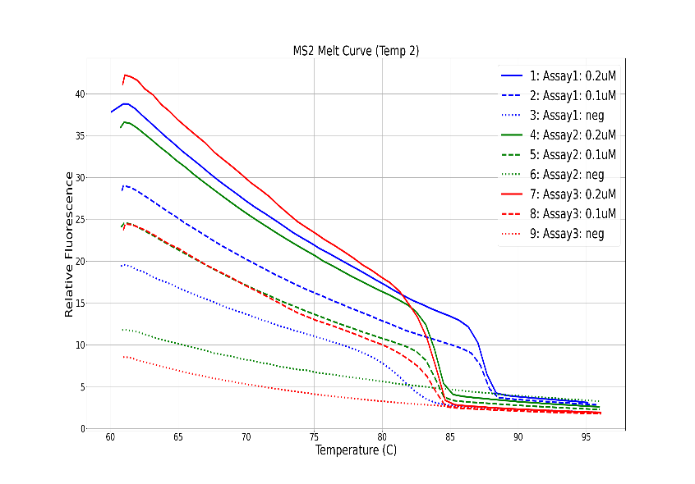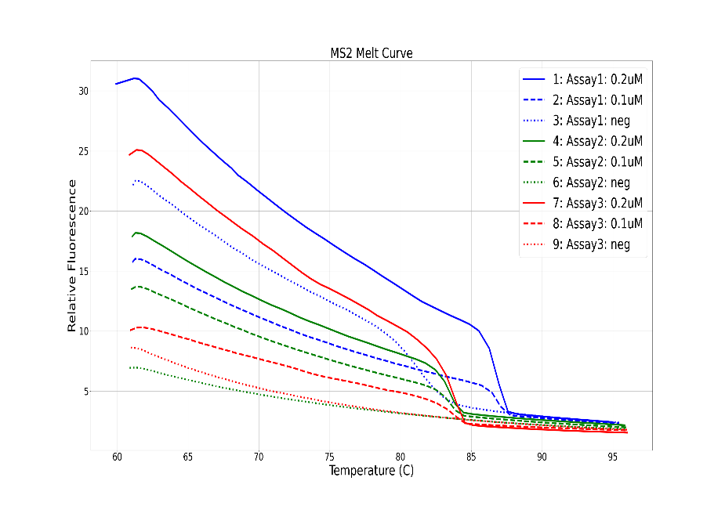

For both temperatures, there was significant amplification for the Assay1 negative control which suggests possible contamination or the presence of primer-dimers.

*This value was estimated and not calculated from the LS32. For Assay1 on Temp 1, the LS32 calculated the Cp value for the negative control and not the 0.1uM concentration. The Cp value that was calculated for the negative control is 27.92. The LS32 also calculated a Cp value for Assay1 on Temp2 which is 29.59.

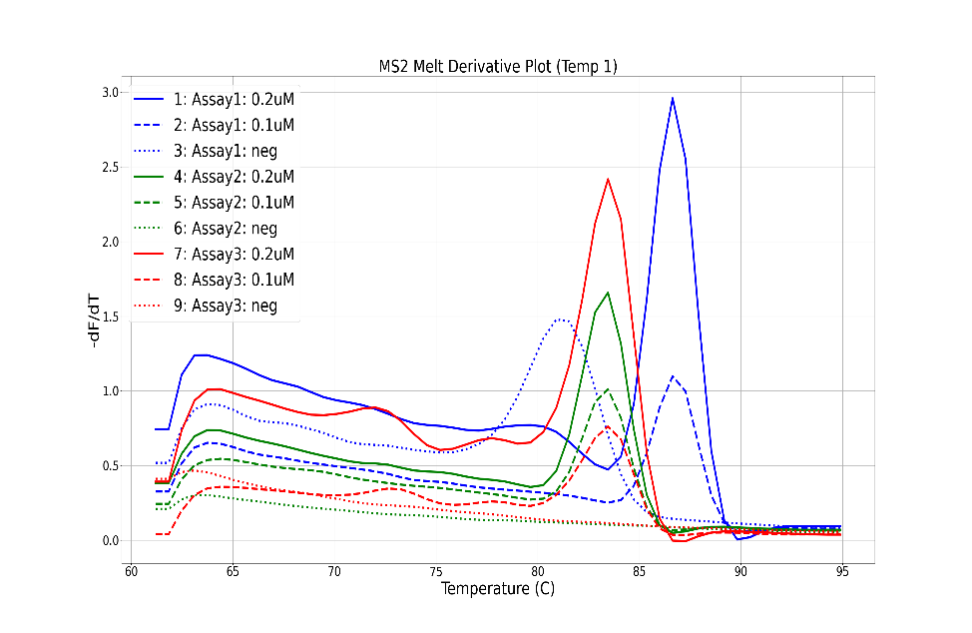

|  |  |
| --- | --- |
| Assay/dilution | Tm value |
| 1/0.2uM | 87.57 |
| 1/0.1uM | 87.35 |
| 2/0.2uM | 83.61 |
| 2/0.1uM | 83.41 |
| 3/0.2uM | 83.09 |
| 3/0.1uM | 82.88 |

|  |  |
| --- | --- |
| Assay/dilution | Tm value |
| 1/0.2uM | 86.90 |
| 1/0.1uM | 86.57 |
| 2/0.2uM | 83.06 |
| 2/0.1uM | 83.14 |
| 3/0.2uM | 82.93 |
| 3/0.1uM | 82.40 |

